NYS FIELD MEMO
Date: December 9, 2016

To: Superintendents of Non-Receivership Schools implementing a 1003(g) School Improvement Grant (SIG) or a School Innovation Fund (SIF) Grant.
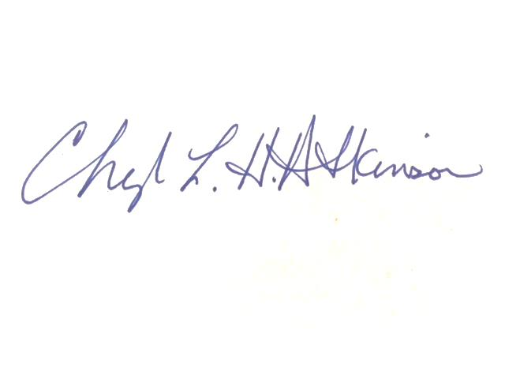
From: Dr. Cheryl Atkinson

Re: 2016-17 Progress Reporting and Performance Management for
Non-Receivership Schools implementing 1003(g) SIG or SIF grants

As part of the New York State Education Department’s effort to hold schools and districts accountable for the results to be achieved in Non-Receivership schools implementing a SIG or SIF grant, the Department’s Office of Innovation and School Reform (OISR) has re-established a progress reporting and performance management process for the 2016-17 school year. This process will continue to consist of the submission of progress reports for each school, by the district, and may include performance review conference calls and on-site monitoring. Calls and site visits will be based on a risk-analysis strategy. Risk-Analysis includes a review of these three areas: (1) the school’s NYS assessment data within the past three years, (2) a review of schools in districts new to SIG, and (3) a focus on SIG 7 schools implementing the New York State Education Department’s state-determined model, the Innovation and Reform Framework.

Progress Reporting for Non-Receivership Schools Implementing SIG or SIF Grants
Non-Receivership schools implementing a SIG or SIF grant will be required to complete two reports annually. The first mid-year report will be due on January 30, 2017, and the second required report will be the SIG/SIF Continuation Plan for 2017-18 which will be due on April 28, 2017. The mid-year report template is attached and will also be posted on the OISR website.

Performance Review Conference Calls for Non-Receivership Schools Implementing SIG or SIF Grants
Again, performance review calls will only be held with Non-Receivership schools implementing a SIG or SIF grant on a risk-analysis basis. If a performance review call is requested, your OISR liaison will contact district staff to schedule the call.

On-site Monitoring for Non-Receivership Schools Implementing SIG or SIF Grants
OISR staff may conduct on-site visits to any one or a number of schools receiving SIG or SIF Grants, on a risk-analysis basis. The following guiding questions are used to frame the monitoring visits:

  - Does the school climate appear to be safe and conducive to learning?
  - How well does school leadership articulate key strategies for turning around the school?
  - What are the on-going results observed by school leadership and how well do they predict the likelihood of meeting school goals?
  - To what degree is the SIG/SIF funding impacting the school turnaround efforts; to what degree is leadership planning for sustainability of these efforts; and is there evidence of fiscal compliance with regard to the approved FS-10 expenditures?
Supporting fiscal documents should be available upon request.

On-site monitoring visits may be conducted with or without notification and district staff may or may not need to be present. Debriefing may occur on-site at the time of the visit, at the district office at the conclusion of a series of visits, or as a written follow-up site visit report emailed to the district Superintendent.

Additional Information
Additional report templates and SIG/SIF resources may be found at the OISR website at 16-17 NR schools PM memo 12-9-16.docx, which will continually be updated. The first report is due January 30, 2017 and should be submitted to the OISR@nysed.gov mailbox.

As applicable, the Final Expenditure Forms or FS-10Fs, for 2015-16 SIG or SIF grants were due to the Department within 90 days of the end date of the grant. All 2015-2016 SIG and SIF budget periods ended no later than August 31, 2016. The FS-10F forms can be found here: http://www.oms.nysed.gov/cafe/forms/.

Once FS-10Fs have been processed and approved, SIG 6 schools can access 2015-2016 carryover by submitting FS-10As to increase their 2016-17 budgets.

Non-Receivership Schools implementing SIG 7 models should be prepared to discuss how they met the post-award requirements that were to be in place within 30 days of receipt of preliminary award letters. (This information is delineated in the SIG 7 RFP on pages 17-18, and is posted at: http://www.p12.nysed.gov/funding/1003g-school-improvement-grant-sig-7/home.html.)

Lastly, updated SIG and SIF “School-level Baseline Data and Target-Setting Charts”, or “Attachment Bs”, were due for all Non-Receivership SIG 3, 4, 5, and 6 and SIF 3 schools by August 31, 2016. Updated Attachment Bs were to be emailed by October 31, 2016. SIG 7 schools provided an Attachment B as part of their applications. Attachment Bs will be referenced during calls and site visits; and should be referenced in reports.

If you have any additional questions, please feel free to contact your Office of Innovation and School Reform liaison at 518-473-8852 or at OISR@nysed.gov.

Thank you in advance for your cooperation and support and thank you for your continued work to improve the educational outcomes of the students in New York State.

